

DRAFT
Technical Design

Melbourne IT OFC
MIT OFC iExpense Workflow: One Approval Email

Author: Tony Whelan
Creation Date: 10 April 2017
Last Updated: 10 April 2017
Version: 1.0
Table of Contents

1. MIT Requirements 3
2. Proposed Solution 3
3. Workflow Modification 4
4. Test Scenarios 6
4.1 Existing Workflow 6
4.2 Proposed Workflow 8
5. DBA Deployment Process 9
6. Outstanding Issues 10

MIT Requirements

The standard seeded Oracle EBS Internet Expense Workflow currently emails an initial Request for Approval message to the employees Manager, followed by 2 additional reminders every 5 days if the original emails are not approved.

This sometimes causes issues when Managers respond to timed-out Request for Approval emails, and also causes confusion as to which email should be actioned by the Manager. In addition, since MIT restricted OFC Internet Expenses to Corporate Credit Card holders, MIT requires the Request for Approval to be emailed only once to approving Managers.

The MIT Payables Team will manage and monitor the claims pending Manager Approval using existing reports and will follow up outstanding claims with Managers and Employees rather than relying on the automated MIT OFC Internet Expense Workflow process.

Proposed Solution

The standard workflow apwxwkfl.wft should be modified to email a single Request for Approval for Internet Expense claims. No more emails should be generated until the initial email is approved.

Workflow Modification

Open the Expenses Workflow in Oracle Workflow Builder
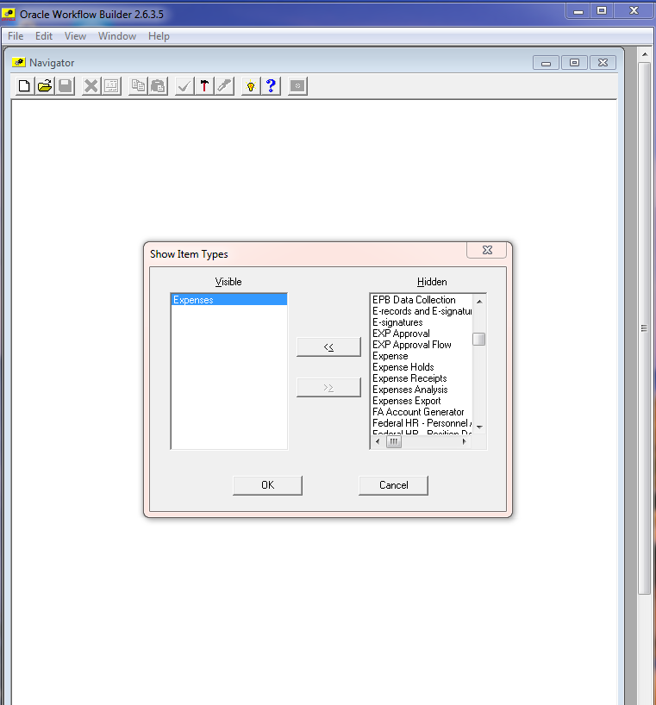

Open the Request Approval Process
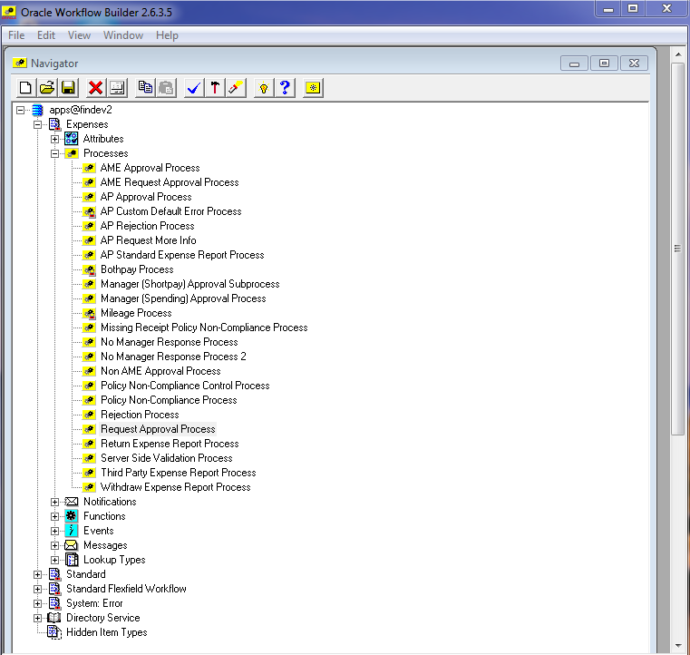

Open the Request Approval from APROVER performer
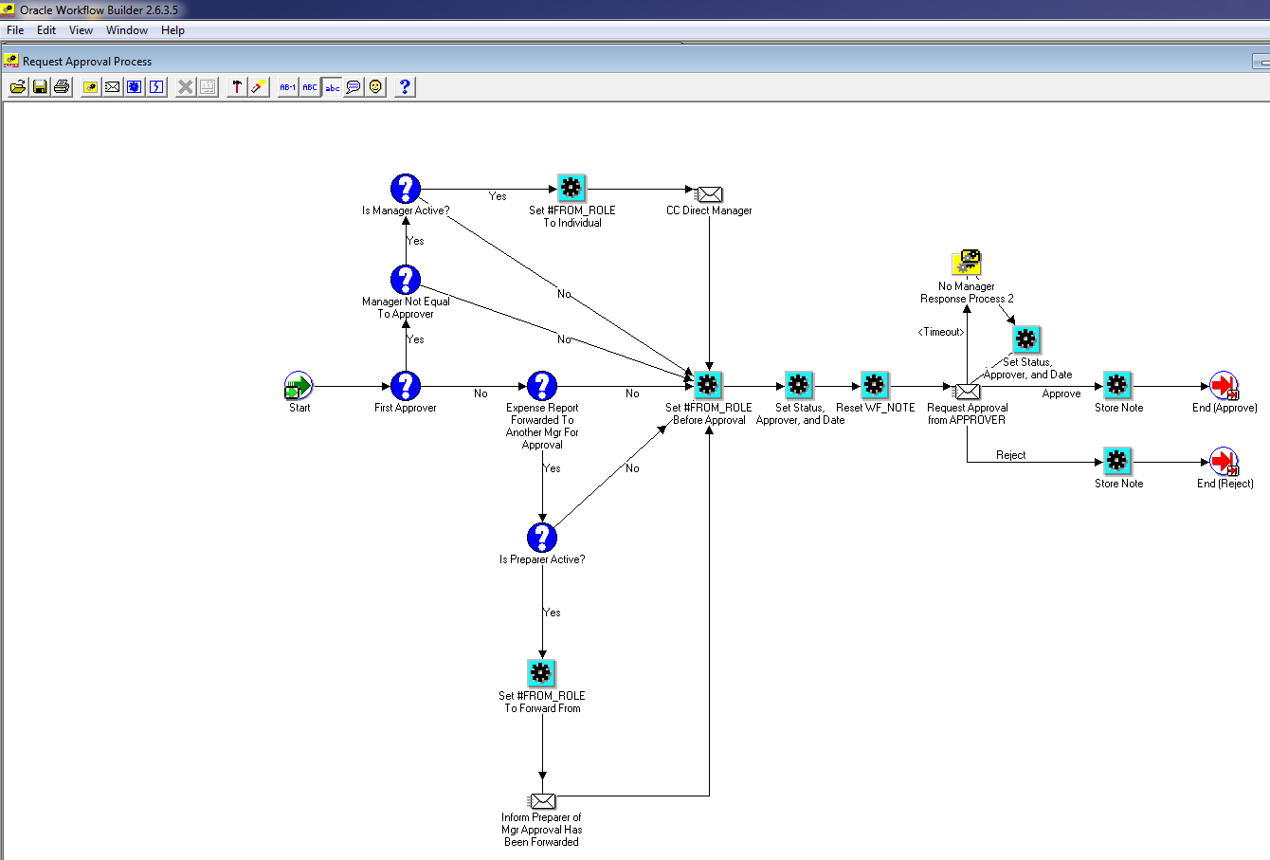

Change the Timeout Type field.
Change the Timeout Type field in the Node TAB from Relative Time of 5 days to No Timeout.
Save the change to the Workflow.

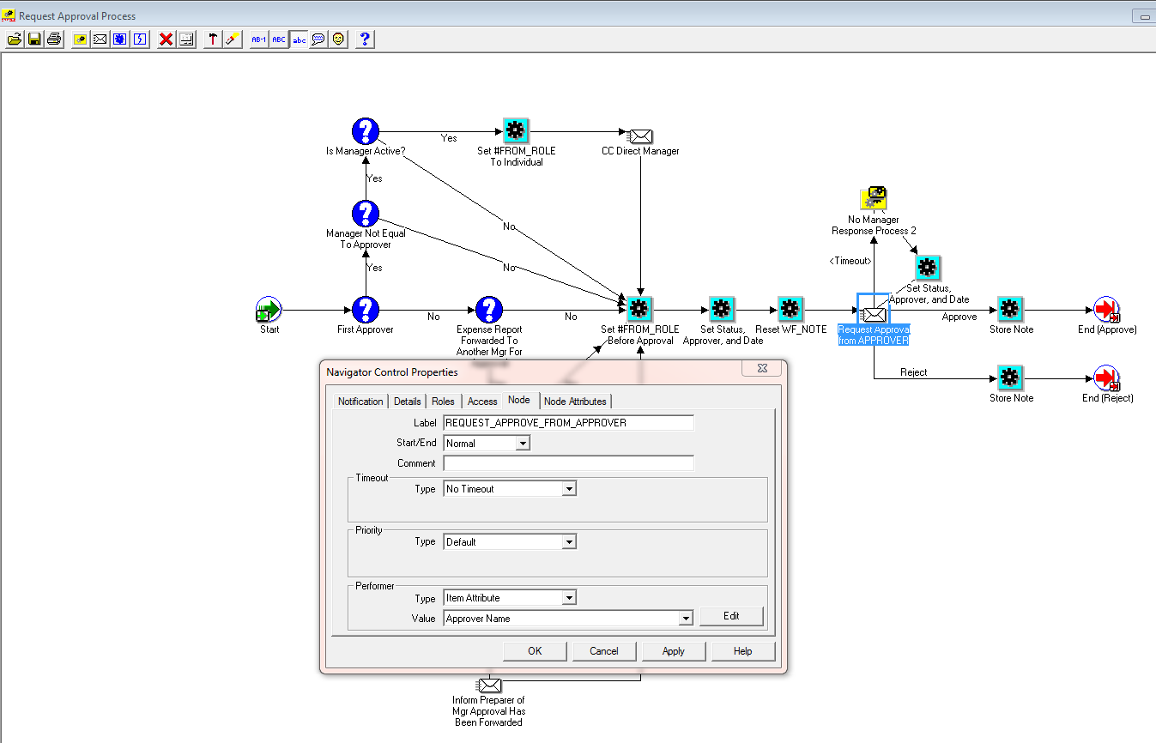

Test Scenarios
The following test scenarios were performed to verify the change to the workflow:

Existing Workflow
The Timeout Period was initially changed to 10 minutes to verify the existing process in a short period of time.

The following Request for Approval emails were generated under the existing Workflow:-

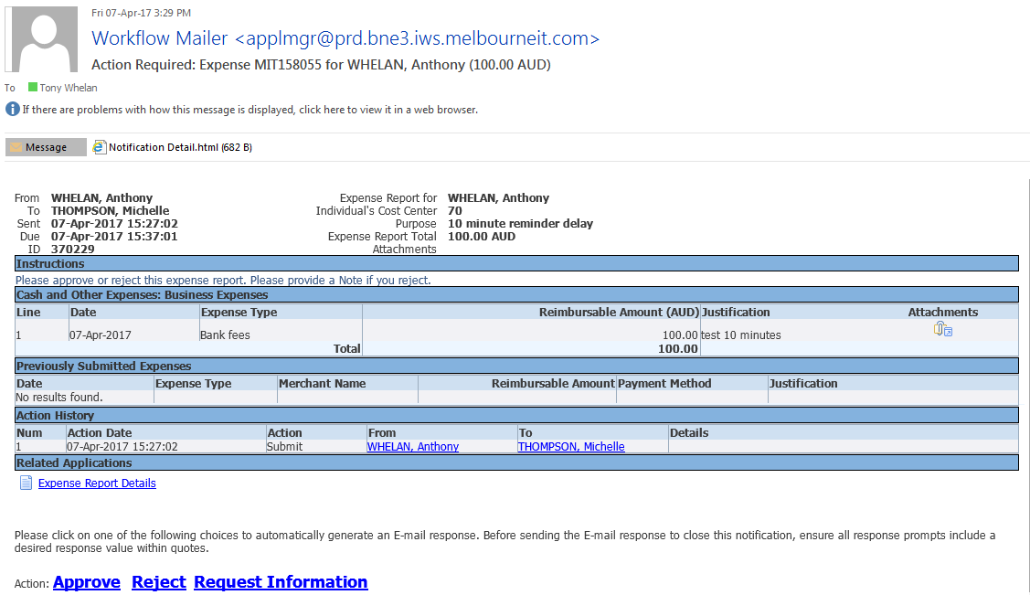

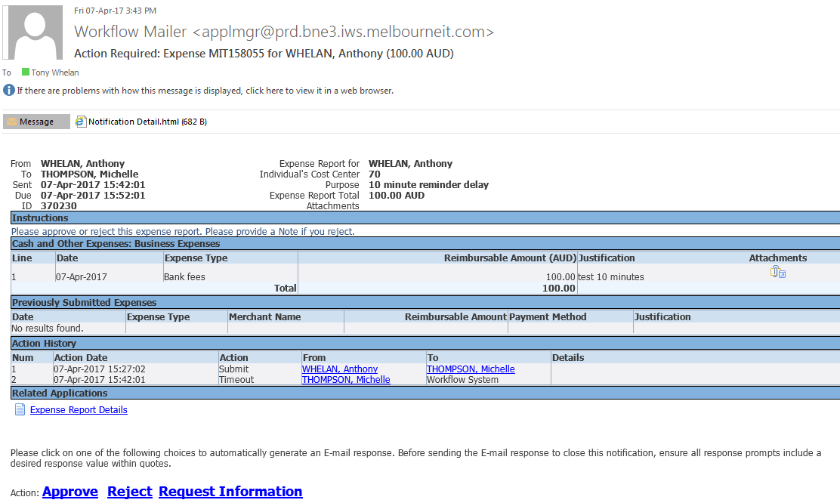

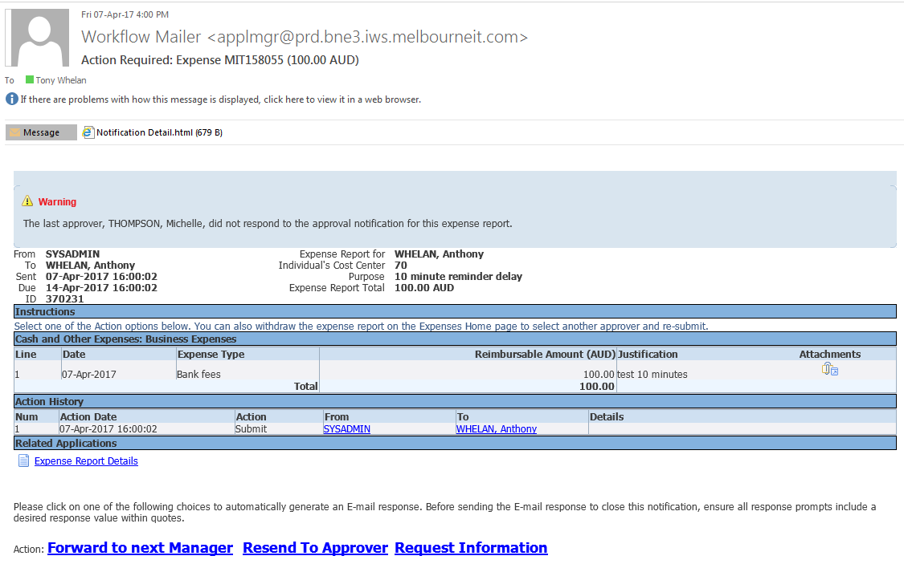

Proposed Workflow
The Timeout Period was then changed to No Timeout.
The following emails were generated under the changed No Timeout scenario:-

- Initial Request for Approval Email
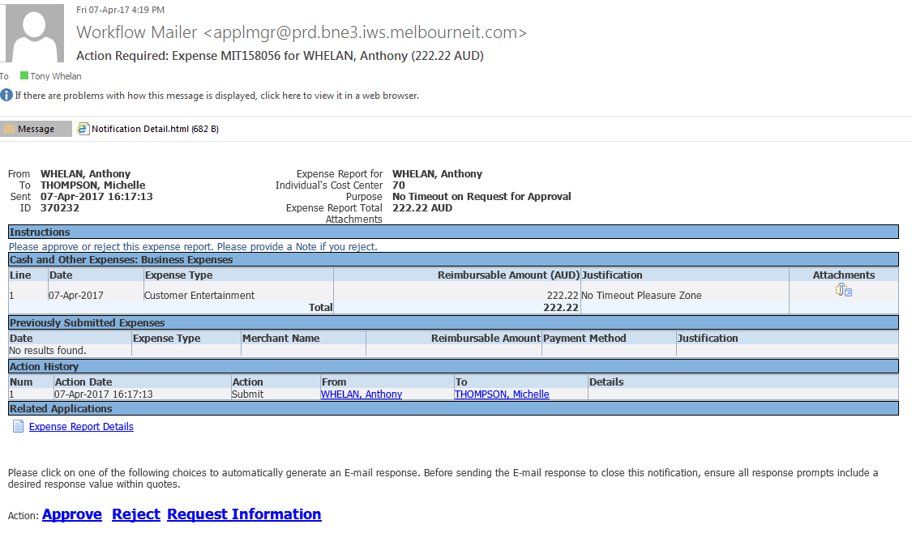

- No more email were generated until the initial Email was approved:-
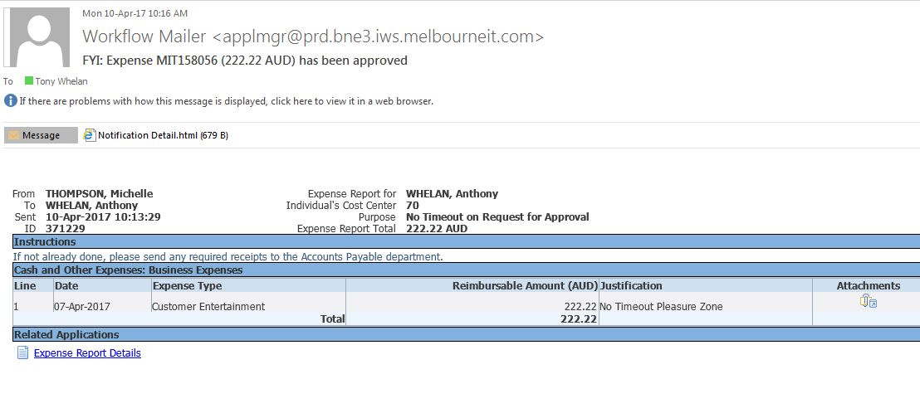

DBA Deployment Process
DBA tasks to deploy this program to OFC Production:-

Make a backup copy of the production apwxwkfl.wft file;
On Production as applmgr
cd /app/R12/appl/apps/apps_st/appl/ap/12.0.0/patch/115/import/US
cp apwxwkfl.wft apwxwkfl.bck

Copy apwxwkfl.wft from findev2 to production:
scp findev2.melbourneit.com:/app/R12/appl/apps/apps_st/appl/ap/12.0.0/patch/115/import/US/apwxwkfl.wft

Upload the workflow file using WFLOAD utility from linux production directory
WFLOAD apps/password 0 Y FORCE apwxwkfl.wft

You should receive messages similar to the following after the WFLOAD command:-
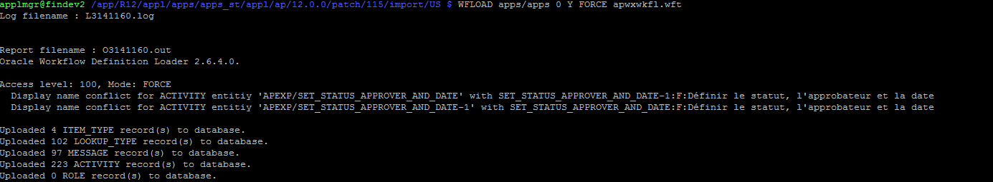

Outstanding Issues

